Task 23

DataBase Connectivity

Q1.

Create Table Empl:

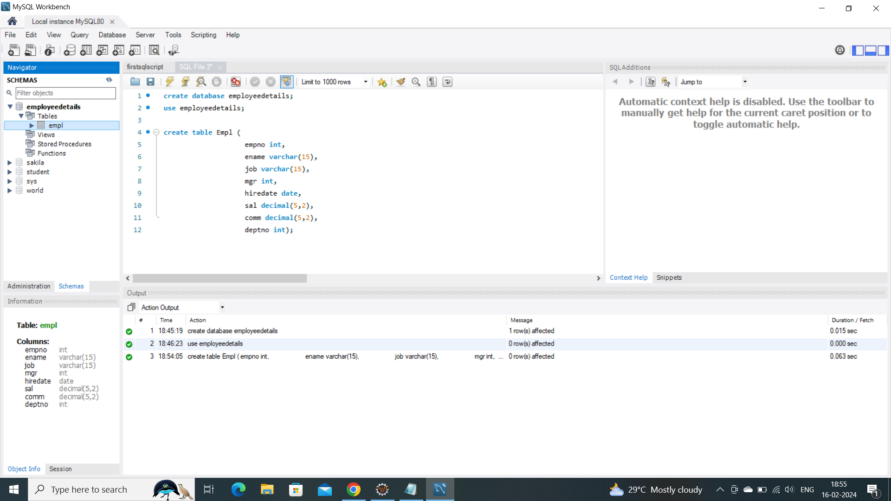

Insert values in Empl table:

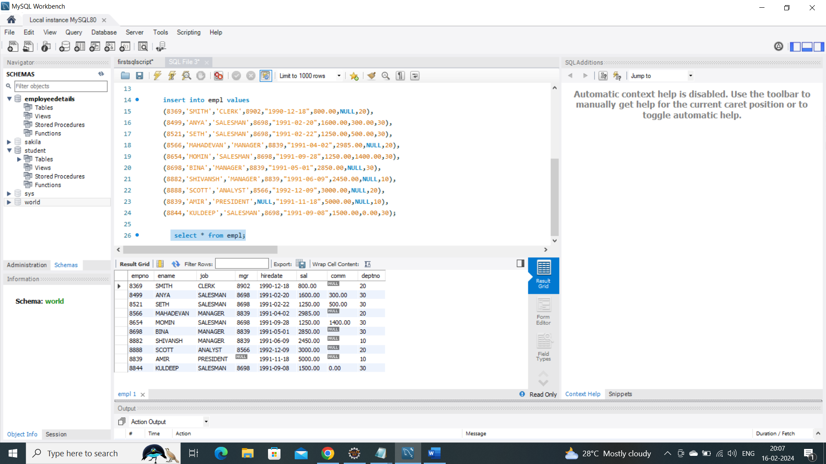

1.A) write a query to display ename and sal of employees whose salary are greater than or equal to 2200.

Query:

select ename,sal from empl where sal>=2200;

output:

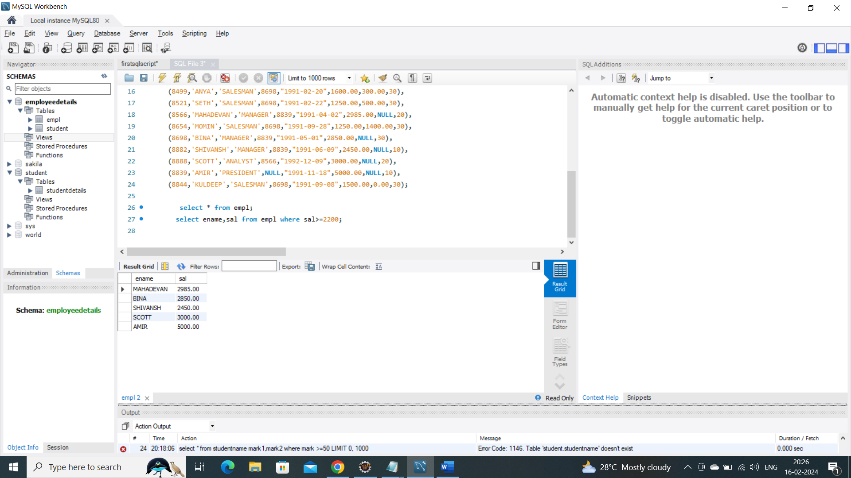

B) write a query to display details of employee who are not getting commission

Query:

select * from empl where comm is null;

Output: 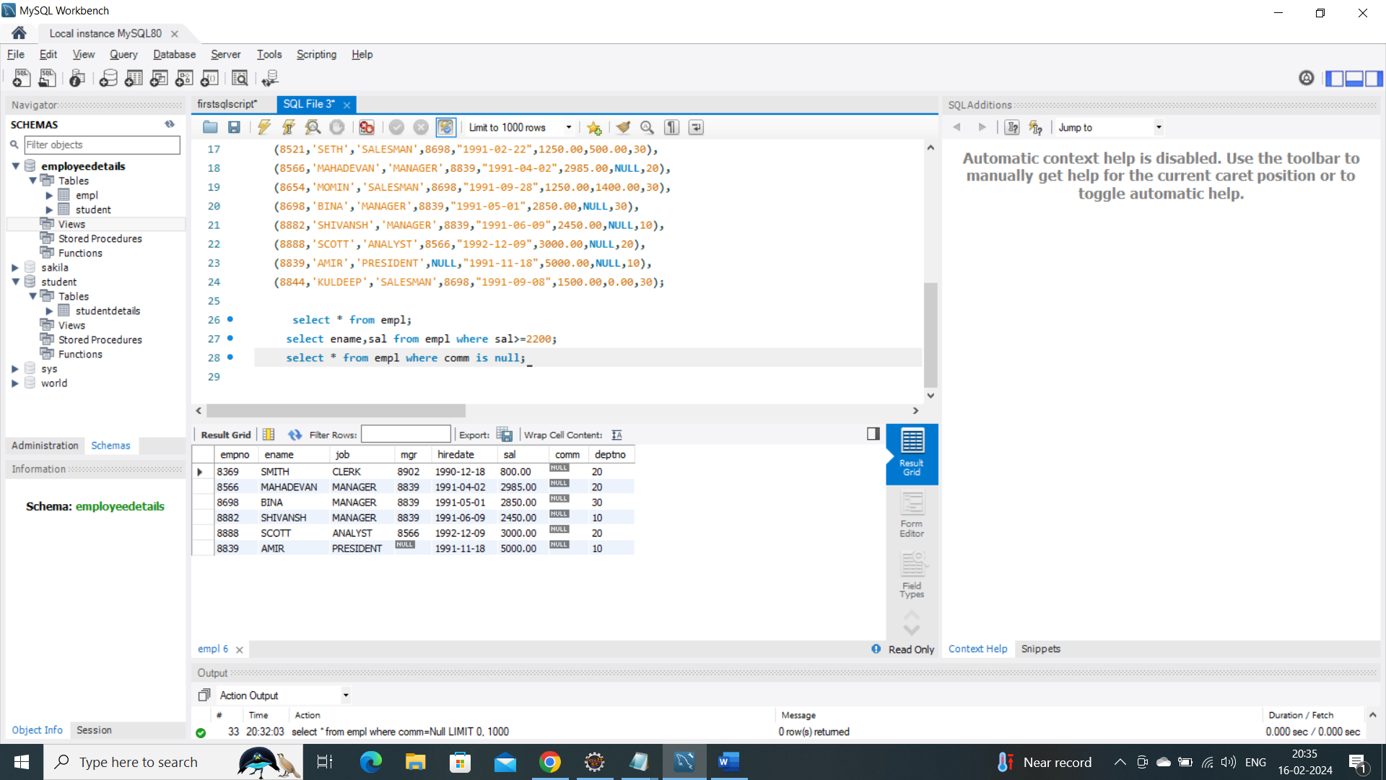

C) Write a query to display employee name and salary of those employees who don’t have their salary in the range of 2500 to 4000?

Query:

select ename,sal from empl where sal not between 2500 and 4000;

Output:

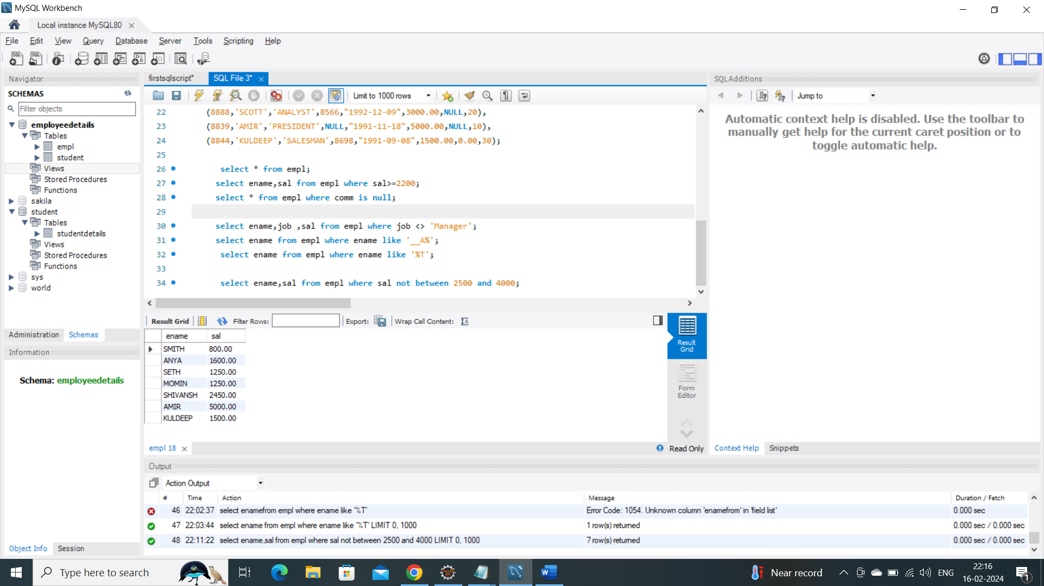

D) write a query to display the name,job title and salary of employees who don’t have a manager.

Query:

select ename,job ,sal from empl where job <> 'Manager';

Output:

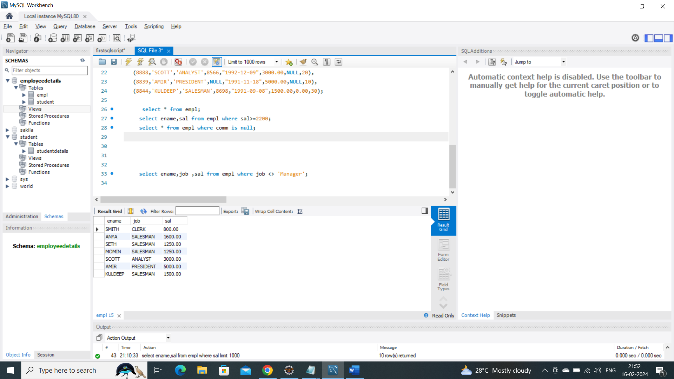

E) Write a query to display the name of an employee whose name contains “A” as third Alphabet?

Query:

select ename from empl where ename like '__A%';

Output:

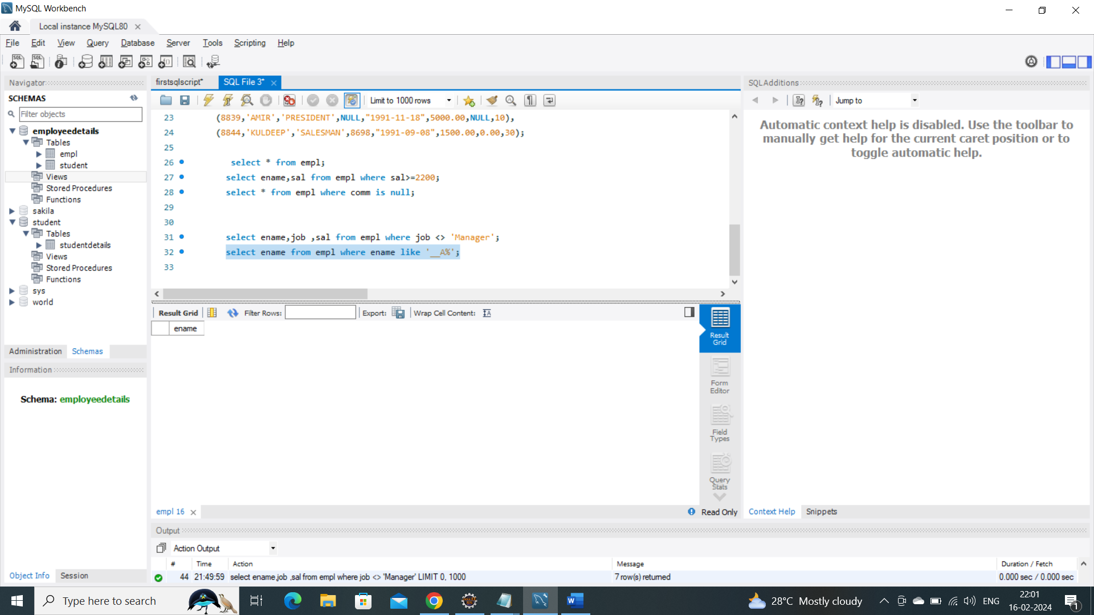

F) write a Query to display the name of an employee whose name contains “T”

As the last Alphabet?

Query:

select ename from empl where ename like '%T';

Output:

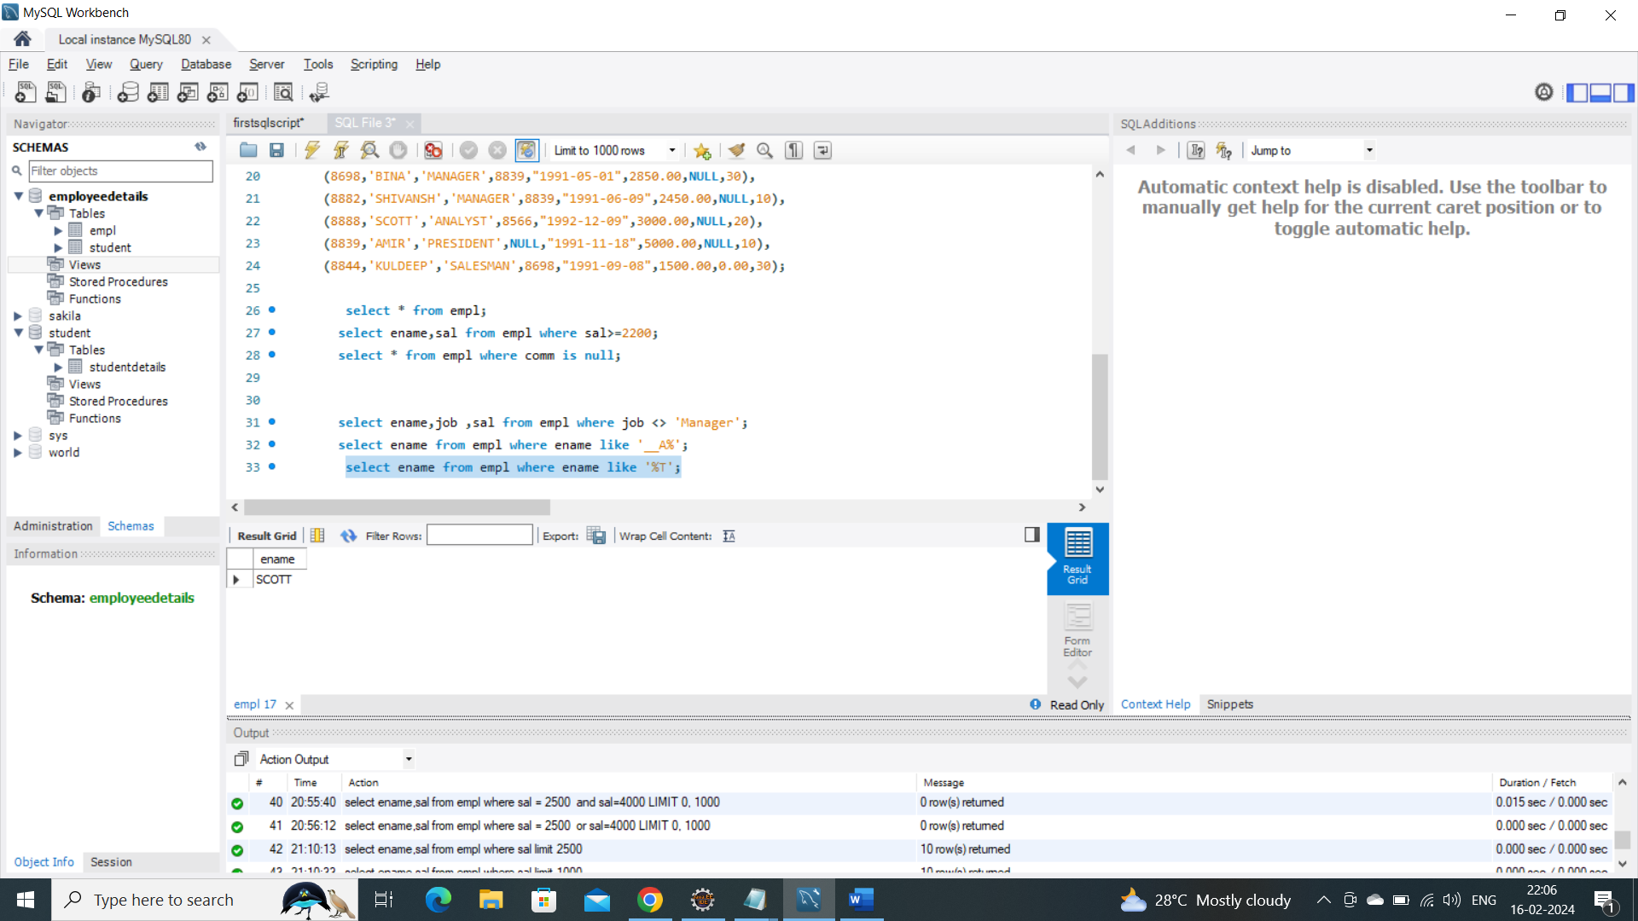

2) Write a program for JDBC to connectivity and insert the datas:

Script:

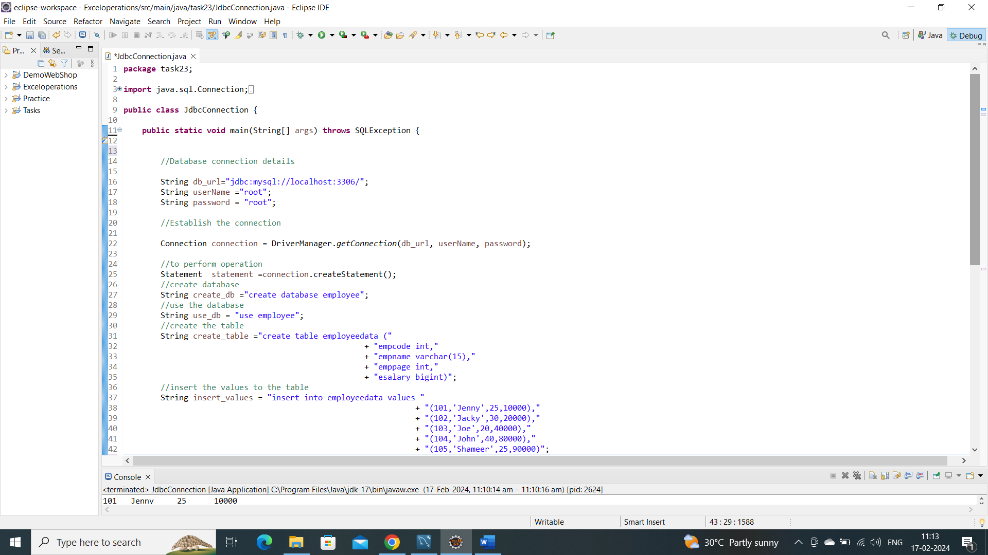

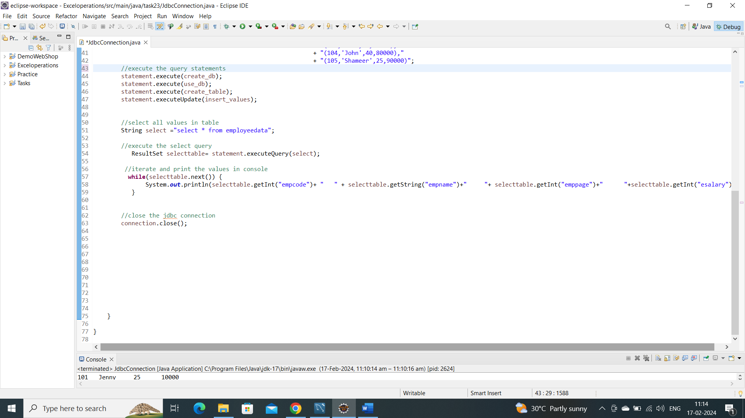

Console output:

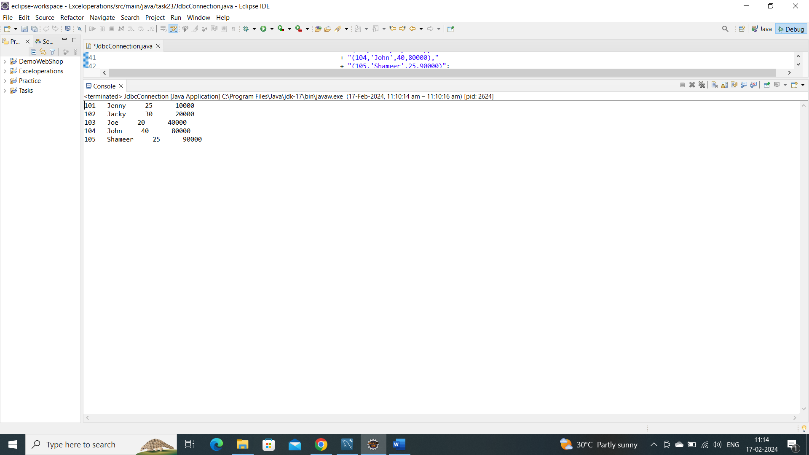

Database and table in workbench:

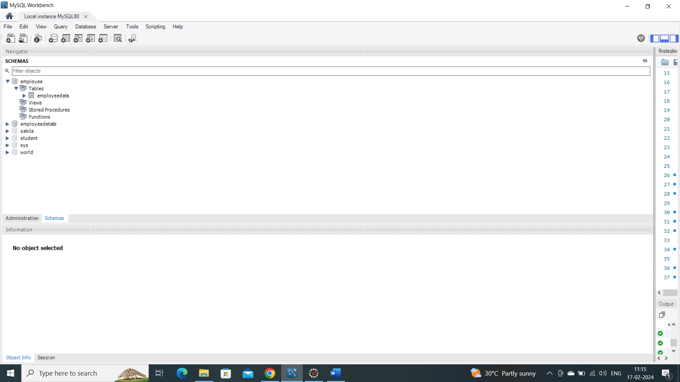

Table values in workbench:

